GUARDRAIL ON BRIDGE, CASE II
GUARDRAIL ON TOP OF BRIDGE CURB

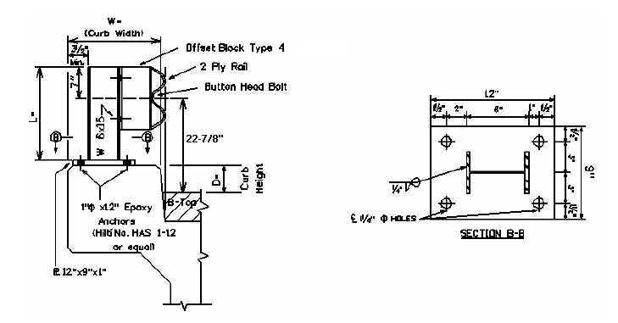
24-7/8”

Bridge MP | D = | W = | L = | No. Posts | LF of 2 PLY Rail

D = Curb Height W = Width of Bridge Curb L = Length of Guardrail Post

Warrants: When guardrail can be bolted to the top of the bridge curb and curb width is 12 inches or greater, remove existing concrete and/or guardrail bridge rail and use Case II Bridge Guardrail.

NOTES:

- If the clear distance between the faces of the guardrail for the Case II guardrail is less than 22 feet, delete the offset block.

- When Case II Guardrail is used without the offset block, use a Precast Concrete Bridge Block at the ends of the bridge which face opposing traffic. See detail drawing for Precast Concrete Bridge Block.

